Chapter 10, Solution 27.

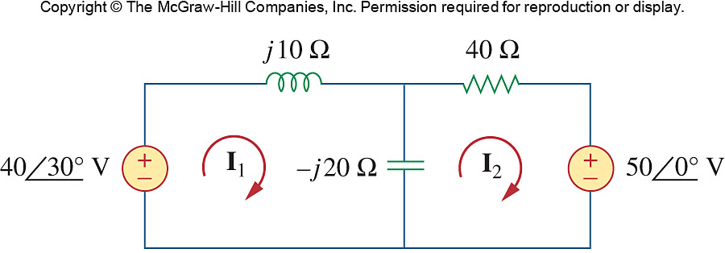
Using mesh analysis, find I₁ and I₂ in the circuit of Fig. 10.75 as shown in the text.

Figure 10.75
For Prob. 10.27.

Solution

For mesh 1,
(1)

For mesh 2,
(2)

From (1) and (2),

4.69895.24 A

992.837.71 mA

